To,
The Case Officer,
UKVI,
Home Office

15 October 2026
UAN: 1212-0001-6479-0157
Re: Skilled worker dependant visa application – Mr Dino Dominic

Dear Sir/Madam,
We write as immigration advisers on behalf of our client, Mr Dino Dominic, in support of his application for permission to remain in the United Kingdom as the partner of Mrs Aparna Jose, who holds permission under the Skilled Worker route.
We trust that the enclosed documentation provides sufficient evidence to support the application. However, should any further information, clarification or documentation be required, we would be grateful for the opportunity to provide this.
Thank you for your time and consideration of this application. We respectfully request that the application be considered favourably.
Sincerely,
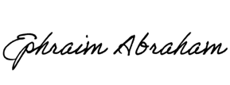
Ephraim Abraham
Immigration Advisor
ephraim@l-cedar.com

